Project Synopsis

on

**KConnect**

Submitted as a part of course curriculum for

**Bachelor** **of**

**Technology**

in

**Computer** **Science**



**Submitted by-**

Sandhya Singh

(1900290120099)

Sakshee Varshney

(1900290120094)

Shivi Saxena

(1900290120110)

**Under the supervision of:**

Ms. Anshula Gupta

( Assistant Professor)

**KIET** **Group** **of** **Institutions,** **Ghaziabad** **Department** **of** **Computer** **Science**

**Dr.** **A.P.J.** **Abdul** **Kalam Technical** **University**

2021-2022

**DECLARATION**

We hereby declare that this submission is our work and that, to the best of our knowledge and belief, it contains no material previously published or written by another person nor material which to a substantial extent has been accepted for the award of any other degree or diploma of the university or other institute of higher learning, except where due acknowledgement has been made in the text.

Signature of Students :

Name: Sakshee Varshney(1900290120094)

Sandhya Singh (1900290120099)

Shivi Saxena (1900290120110)

Date:

# CERTIFICATE

This is to certify that Project Report entitled “**KConnect**” which is submitted by Shivi Saxena ,Sandhya Singh, Sakshee Varshney in partial fulfilment of the requirement for the award of degree B. Tech. in Department of Computer Science of Dr A.P.J. Abdul Kalam Technical University, Lucknow is a record of the candidates own work carried out by them under my supervision. The matter embodied in this report is original and has not been submitted for the award of any other degree.

**Date:** **Supervisor** **Signature**

Ms. Anshula Gupta

(Assistant Professor)

# ACKNOWLEDGEMENT

It gives us a great sense of pleasure to present the synopsis of the B.Tech Mini Project undertaken during B.Tech. Third Year. We owe a special debt of gratitude to Ms. Anshula Gupta (Assistant Professor), Department of Computer Science, KIET Group of Institutions, Delhi- NCR, Ghaziabad, for her constant support and guidance throughout the course of our work. Her sincerity, thoroughness and perseverance have been a constant source of inspiration for us. It is only his/her cognizant efforts that our endeavours have seen the light of the day.

We also take the opportunity to acknowledge the contribution of Dr. P. K Singh, Head of the Department of Computer Science, KIET Group of Institutions, Delhi- NCR, Ghaziabad, for his full support and assistance during the development of the project. We also do not like to miss the opportunity to acknowledge the contribution of all the faculty members of the department for their kind assistance and cooperation during the development of our project.

Last but not the least, we acknowledge our friends for their contribution to the completion of the project.

Date :

Name :Shivi Saxena(1900290120110)

Sandhya Singh(1900290120099)

Sakshee Varshney(1900290120094)

# Abstract

Taking into consideration the pandemic period, students are the ones who have gone through the worst phase. Pandemic has created a communication gap between students that led to lack of information.

KConnect is a bridge to reduce this gap in case of such emergency.

KConnect will work as a networking platform for students of KIET. This platform will help students to interact with seniors. Solve their queries regarding placements, college, clubs, curriculum and many more.

**Features of KConnect**

Home page : Including a search bar, community questions , relevant navigation menus.

User Profile: A page where users can access and update their information.

A page where users can post questions.

Unique question itself and hosting a section. This will for include users the to contribute

answers.

# Problem Statement

In case of uncontrollable situations like pandemic, students are unable to interact with seniors. They could not communicate and clear their doubts with peers and seniors. Also, connecting with alumni is a difficult task in such times. Placement queries could not be resolved because of less interaction.

# Objective

To enable the students to have a better communication opportunity by providing a dedicated platform. Doubt clearing conversation between peers. Connecting with alumni .Resolving placement queries Improving college Experience.

1. **A review and analysis of technologies for developing web applications .**

In this paper we review technologies useful for design and development of web - based applications. We also discuss about the technologies that are used at the client side and server side of web application. Next, we compare different web application development frameworks. In addition, we discuss life cycle model and framework of web application development.

There are a number of benefits of using standards for web application development

including

(i) consistent design style across websites within the organization,

(ii) standardization

of web application requirements document, and

(iii) guidance for testing the websites

2**. Towards a Usability Evaluation Process for Model- Driven Web Development**

This paper presents an approach to integrate usability evaluations into Model-Driven Web development processes . Our main motivation is to define a generic usability evaluation process which can be instantiated into any concrete Webdevelopment process that follows a Model-Driven Development(MDD) approach.

A preliminary version of a Web Usability Model was defined in order to support this usability evaluation process at several stages. This Web Usability Mode l decomposes the usability sub-characteristics (from the Software Quality Model proposed in the ISO/IEC 25000 Sq standard) into other sub-characteristics and measurable attributes. Web metrics are intended to be associated to measurable attributes in order to quantify them. Our approach is intended to perform usability evaluations at several stages of a Web Development process. In this paper, we show how usability evaluations at final user interface (UI) can provide feedback about changes in order to improve usability issues at intermediate artifacts (Platform-Independent Models and Platform-Specific Models) or at transformations rules among these intermediate artifacts

1. **Standard Languages for Creating a Database toDisplay Financial Statements on a Web Application**

XHTML and XBRL are the standard languages for creating a database for the purpose of displaying financial statements on web applications. Today, XBRL is one of the most popular languages for business reporting. A large number of countries in the world recognize the role of XBRL language for financial reporting and the benefits that the reporting format provides in the collection, analysis, preparation, publication and the exchange of data(information) which is the positive side of this language.

Here we present all advantages and opportunities that a company may have by using the XBRL format for business reporting. Also, this paper presents XBRL and other languages that are used for cr eating the database, such XML, XHTML, etc. The role of the AJAX complex model and technology will be explained in detail, and during the exchange of financial data between the web client and web server .Here will be mentioned basic layers of the network for data exchange via the web.

4.**A Revised Web Objects method to estimate Web application development effort**

We present a study of the effectiveness of estimating web application development effort using Function Points and WebObjects methods, and a method we propose –

the Revised WebObjects (RWO). RWO is an upgrading of WO method, aimed to account for new web development styles and technologies. It also introduces an up-front classification of web applications according to their size, scope and technology, to further refine their effort estimation. These methods were applied to a data-set of 24 projects obtained by Datasiel spa, a mid-sized Italian company, focused on web application projects, showing that RWO performs statistically better than WO, and roughly in the same way as FP.

5**.Web development: estimating quick-to-market software**

Developers can use this new sizing metric called Web Objects and an adaptation of the Cocomo II model called WebMo to more accurately estimate Web based software development effort and duration . Based on work with over forty projects , these estimation tools are especially useful for quick – to - market development efforts.

**Flowchart**

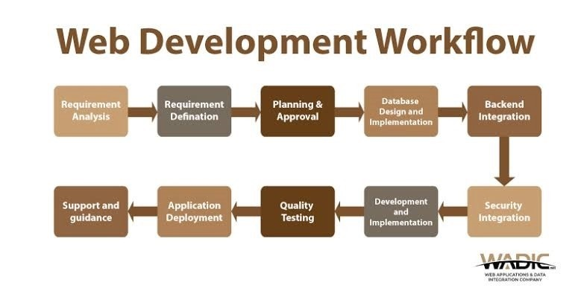

**Technology** **Used**

1. MONGODB
2. EXPRESS.JS
3. REACT
4. NODEJS
5. HTML
6. CSS
7. BOOTSTRAP
8. MACHINE LEARNING

# References

1. D.V. Ferens and D.S. Christensen, "Does Calibration Improve Prediction Accuracy?", *CrossTalk*, vol. 13, no. 4, pp. 14-17, Apr. 2000.
2. Abrahão, S., Iborra, E., and Vanderdonckt J.

2007.Usability Evaluation of User Interfaces Generated with aModel-Driven Architecture Tool. Maturing Usability. Springer HCI series, Vol. 10, 3-32

1. Gómez, J., Cachero, C., and Pastor, O. 2001. Conceptual Modeling of Device-Independent Web Applications. IEEEMultiMedia, Vol. 8(2), 26-39.
2. Olsina, L. and Rossi, G. 2002. Measuring Web Application Quality with WebQEM. IEEE Multimedia,Vol. 9(4), 20-29.
3. L.C. Briand, K. El Emam, F. Bomarius, “COBRA_ A hybridmethod for software cost estimation, benchmarking, and riskassessment”, Proc. of the 20th Int’l Conf. on SoftwareEngineering ICSE 1998, Kyoto, Japan, April 1998, pp. 390-399.